SIMATS ENGINEERING
SAVEETHA INSTITUTE OF MEDICAL AND TECHNICAL SCIENCES
CHENNAI – 602105
Department of Computer Science and Engineering

ASSESSMENT TOOL 3 – Visualization Design Activity

Course Code: | DSA0502 | Course Title: | Query Processing for Data Science
CO Assessed: | CO5 | Assessment: | Tool 3– Visualization Design Activity
Weightage: | 35% | Total Marks:
CO5 Statement: Crea te meaningful visualizations using Pandas and Matplotlib, including charts, distributions, relationships, and interactive visual representations for effective communication
Student Name: | Ishwariya P | Reg. No.: | 192524445
Section / Batch: | B. Tech AI&DS/2025 | Date of Submission: | 20/8/26
Faculty In-charge: | Dr. B. Shyamala Gowri | Project Mode: | Individual Submission

Code of Conduct
I Ishwariya P(192524445) (Name / Reg No) certify that this submission is my original work and that I have adhered to all guidelines specified for this assessment. I understand that any violation of academic integrity rules will result in disciplinary action.
Signature: _________________________

No. | Activity | Task | Student Output | Time
1 | Basic Plot Creation | Create a line plot using a small dataset of monthly sales. Add a title, x-axis label, y-axis label, legend, and grid. | Annotated line plot | 15 min
2 | Plot Component Challenge | Given an incomplete Matplotlib program, identify and add the missing title, labels, legend, markers, and grid. | Corrected Python program | 10 min
3 | Compare Visualization Types | Use the same dataset to create a line plot, bar plot, and scatter plot. Discuss which visualization communicates the data most effectively. | 3 plots + justification | 15 min
4 | Pandas Visualization Activity | Create a DataFrame containing Product, Sales, and Profit. Generate appropriate visualizations directly using Pandas. | DataFrame + plots | 15 min
5 | Trend Visualization | Use monthly/weekly data to identify increasing, decreasing, and fluctuating trends using a line plot. | Trend visualization + analysis | 15 min
6 | Relationship Visualization | Plot two variables such as Advertising vs Sales using a scatter plot. Determine whether the relationship appears positive, negative, or weak. | Scatter plot + interpretation | 15 min
7 | Distribution Visualization | Create a histogram of student marks or employee salaries. Identify the approximate shape, center, spread, and possible skewness. | Histogram + observations | 15 min
8 | Frequency Visualization | Create a categorical dataset such as department-wise employee count. Represent the frequencies using a bar chart. | Frequency chart | 10 min
9 | Scatter Matrix Visualization | Use a dataset containing at least four numerical variables. Generate a scatter matrix and identify the strongest visible relationships. | Scatter matrix + findings | 20 min
10 | Lag Plot Visualization | Use time-series data to create a lag plot. Examine whether the current observation appears related to the previous observation. | Lag plot + conclusion | 15 min
11 | Autocorrelation Visualization | Generate an autocorrelation plot for a time series. Identify lags with relatively strong positive or negative autocorrelation. | Autocorrelation plot + analysis | 20 min
12 | Bootstrap Visualization | Select a numerical dataset, repeatedly resample it, and examine the distribution of a chosen statistic such as the mean. | Bootstrap distribution + interpretation | 25 min

Scatter Matrix Plot & Lag Plot Investigation

1. Scatter Matrix Plot

1.1 Definition
A scatter matrix plot (also called a pair plot) is a grid of small scatter plots that shows the relationship between every pair of numeric variables in a dataset at the same time. If a dataset has n variables, the scatter matrix is an n × n grid, giving a complete picture of how each variable relates to every other variable in a single view.
Think of it as running many two-variable scatter plots together and arranging them neatly in rows and columns, so that instead of drawing and comparing separate graphs one at a time, we get the full relationship picture of the dataset in one figure.

1.2 Purpose and Importance
The main purpose of a scatter matrix is to quickly explore relationships between multiple variables without drawing separate scatter plots one by one. It is a core tool in Exploratory Data Analysis (EDA) because it helps a data analyst decide which variables are worth studying further, which variables are strongly related, and whether the data has any unusual or unexpected patterns before applying statistical or machine learning models.
In a lecture setting, it is useful to remember this simple line: "A scatter matrix answers many small questions — how does X relate to Y, how does Y relate to Z — all at once, instead of one question at a time."

1.3 Why Scatter Matrices Are Useful in Data Analysis
- They save time by showing all pairwise relationships in one figure instead of many separate plots.
- They help identify which variables are correlated, which is useful before building prediction models.
- They reveal the distribution (shape/spread) of each variable through the diagonal plots.
- They help detect outliers that could distort analysis or model accuracy.
- They support early decision-making, such as choosing which variables to keep, combine, or remove.
In short, a scatter matrix is usually one of the very first plots an analyst draws when a new dataset is received, because it gives an instant overview before any deeper statistical work begins.

1.4 Structure of a Scatter Matrix
A scatter matrix is arranged as a square grid. If we have variables A, B, and C, the matrix has 3 rows and 3 columns, giving 9 small plots in total. Each row represents one variable, and each column represents one variable as well, so every variable appears once as a row and once as a column.
As a general rule, for n variables, the grid contains n × n cells, of which n cells lie on the diagonal and (n² − n) cells lie off the diagonal. For our 3-variable example, that is 3 diagonal cells and 6 off-diagonal cells.

1.5 Rows and Columns Interpretation
Each cell in the grid is located at the intersection of a row-variable and a column-variable. The cell in row A and column B shows how variable A relates to variable B. Since the matrix is symmetric, the cell in row B and column A shows the same relationship but with the axes swapped (mirror image). This symmetry means we usually only need to study half of the grid to understand all relationships.

1.6 Diagonal Plots
The plots that lie on the main diagonal of the matrix (where a variable meets itself, such as A vs A, B vs B) are special. Since plotting a variable against itself would just produce a straight diagonal line with no useful information, these diagonal cells instead show the distribution of that single variable — usually as a histogram or a density curve. This tells us the range, spread, and shape (such as whether the data is normally distributed, skewed, or has multiple peaks) of each variable individually.
Lecture note: whenever you see a scatter matrix, always check the diagonal first — it tells you what "normal" looks like for each variable, before you start comparing variables with each other.

1.7 Off-Diagonal Scatter Plots
All the cells that are not on the diagonal are true scatter plots, each comparing two different variables. These off-diagonal plots are where we study relationships — whether two variables increase together, move in opposite directions, or show no clear connection at all.
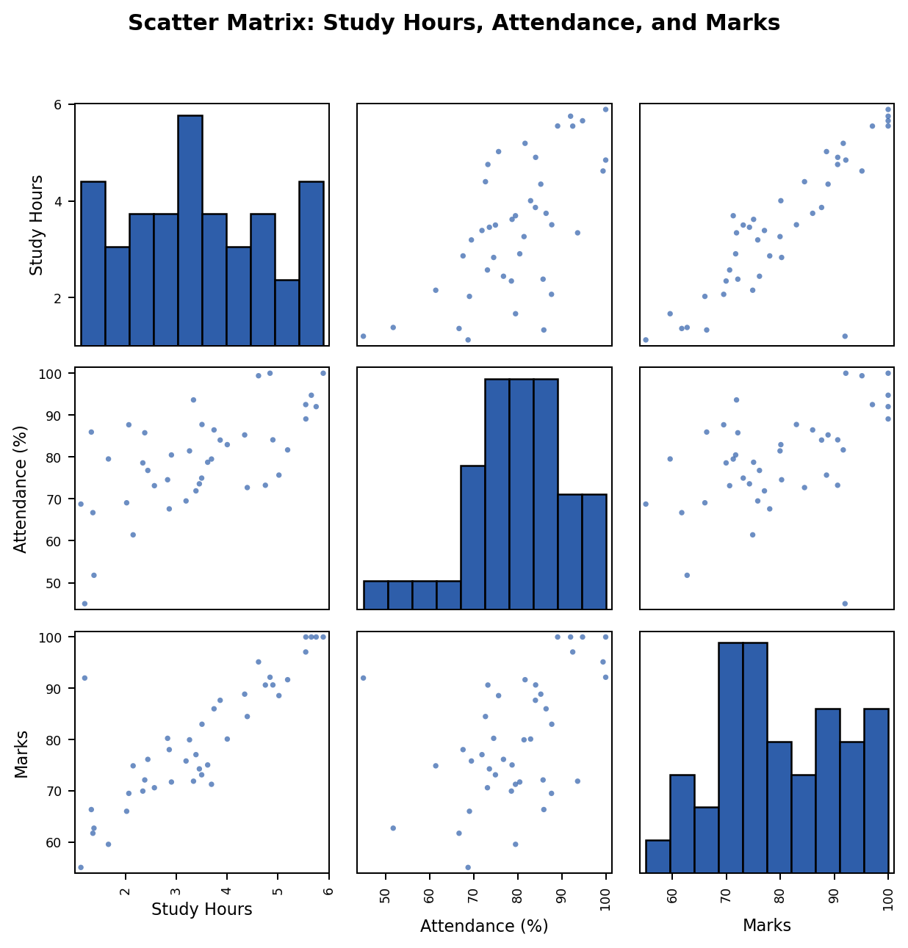
Figure 1: A 3×3 scatter matrix for Study Hours, Attendance, and Marks. Diagonal cells show histograms of a single variable; off-diagonal cells show pairwise scatter plots.

1.8 Identifying Relationships: Positive, Negative, and Weak/No Relationship
The direction and shape of the point-cloud in each off-diagonal cell tells us the type of relationship between the two variables being compared:
Pattern in Scatter Plot | Type of Relationship | Meaning
Points rise from bottom-left to top-right | Positive relationship | As one variable increases, the other also increases
Points fall from top-left to bottom-right | Negative relationship | As one variable increases, the other decreases
Points scattered randomly with no clear direction | Weak or no relationship | The two variables do not meaningfully affect each other
It also helps to notice how tightly the points hug an imaginary line: points packed close to a line indicate a strong relationship, while points spread widely around the same general direction indicate a weaker relationship.
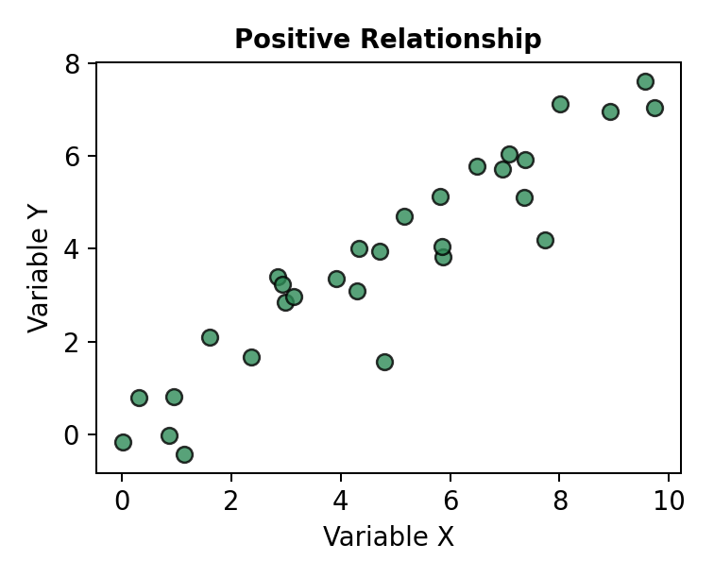
Figure 2: Positive relationship — points trend upward from left to right.
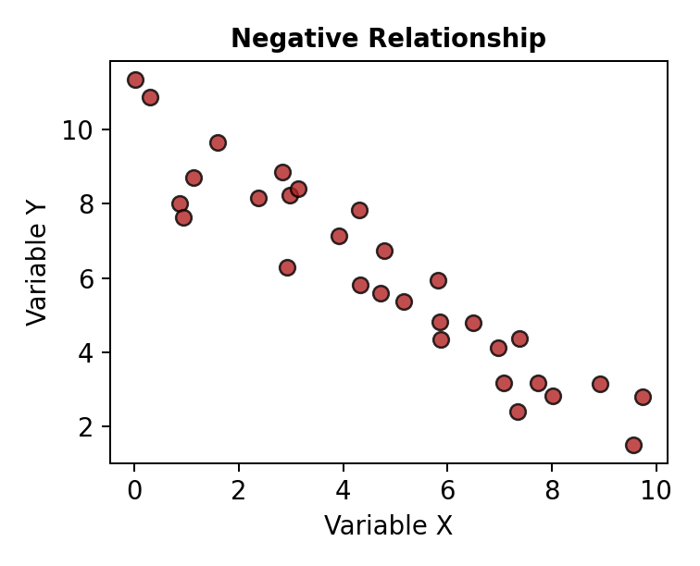
Figure 3: Negative relationship — points trend downward from left to right.
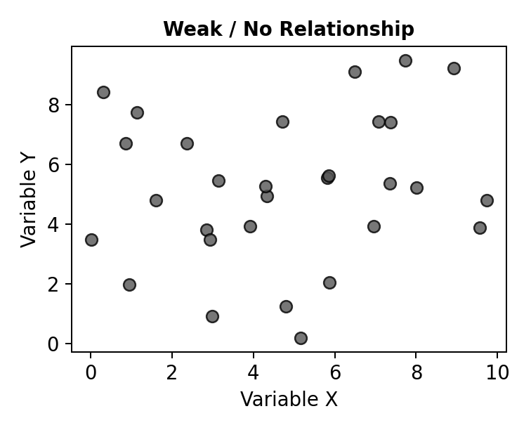
Figure 4: Weak / no relationship — points show no clear direction.

1.9 Identifying Possible Outliers
An outlier is a data point that lies far away from the main cluster of points in a scatter plot. In a scatter matrix, outliers appear as isolated dots that are clearly separated from the rest of the group in one or more of the small plots. Spotting the same unusual point across multiple plots in the matrix helps confirm that it is a genuine outlier and not just a plotting error, and analysts can then investigate whether it should be corrected, removed, or studied separately.
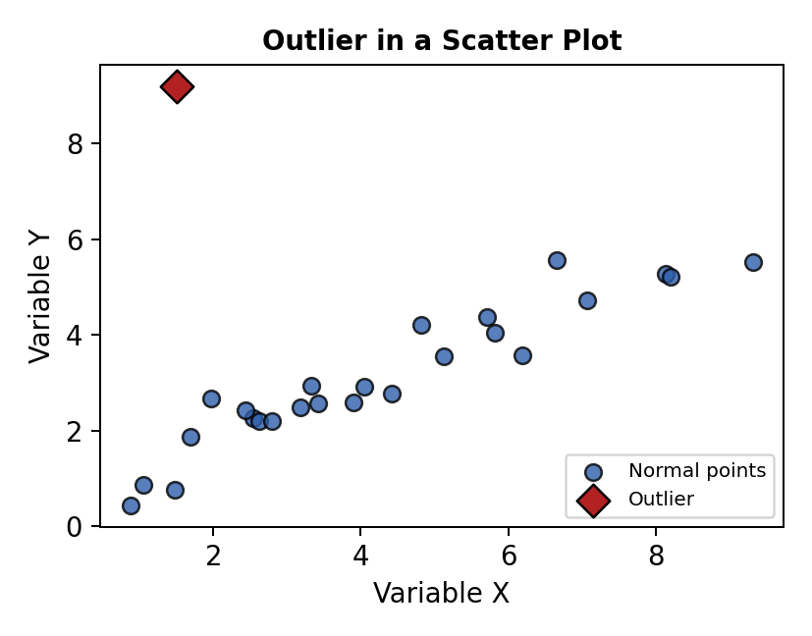
Figure 5: An outlier (diamond marker) sitting far away from the main cluster of points.

1.10 Real-World Example: Student Study Hours, Attendance, and Marks
Consider a dataset collected from a class of students with three variables:
Variable | Meaning
Study Hours | Number of hours a student studies per day
Attendance (%) | Percentage of classes attended by the student
Marks | Final marks scored by the student in the exam

1.11 Explaining the Example
For this dataset, a scatter matrix would be a 3 × 3 grid covering Study Hours, Attendance, and Marks, exactly as shown in Figure 1 above. The diagonal cells show the distribution of Study Hours, Attendance, and Marks individually — for example, whether most students study 2–4 hours a day. The off-diagonal cells let us investigate real questions, such as:
- Study Hours vs Marks — Do students who study more hours tend to score higher marks? (We would expect a positive relationship.)
- Attendance vs Marks — Does higher attendance lead to better marks? (Likely a positive relationship, though maybe weaker.)
- Study Hours vs Attendance — Do students who attend more classes also study more at home, or are these independent habits? (This may show a weak or no relationship.)
By looking at all three comparisons together in one scatter matrix, a teacher or analyst can quickly understand which factor (study hours or attendance) has a stronger influence on marks, and can also spot any student who is an outlier — for example, someone with very low attendance but unexpectedly high marks, as illustrated conceptually in Figure 5.
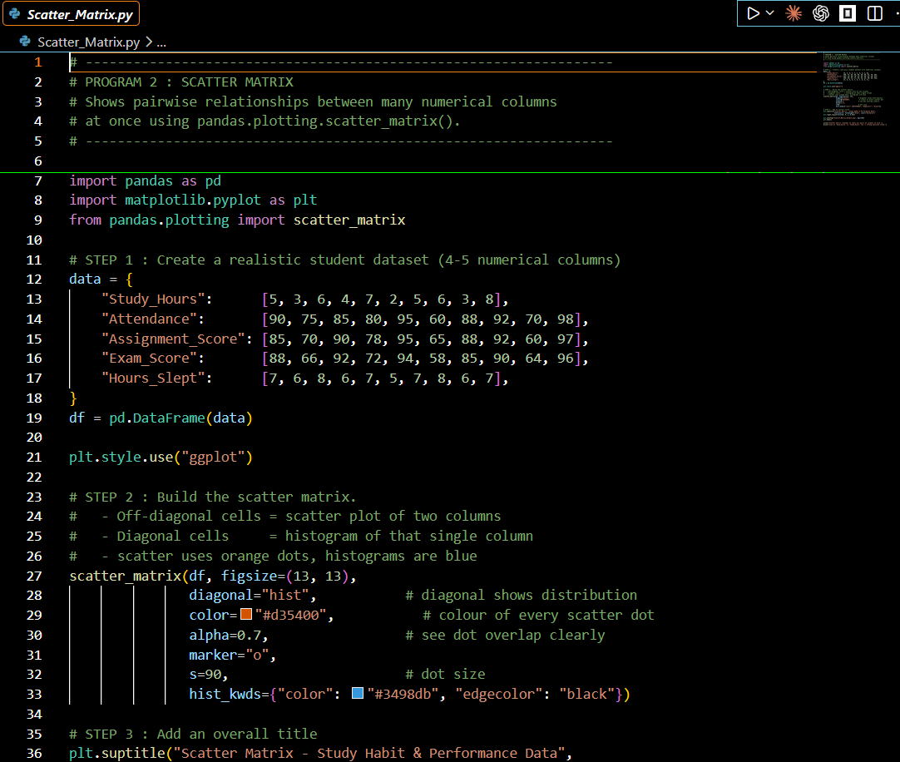

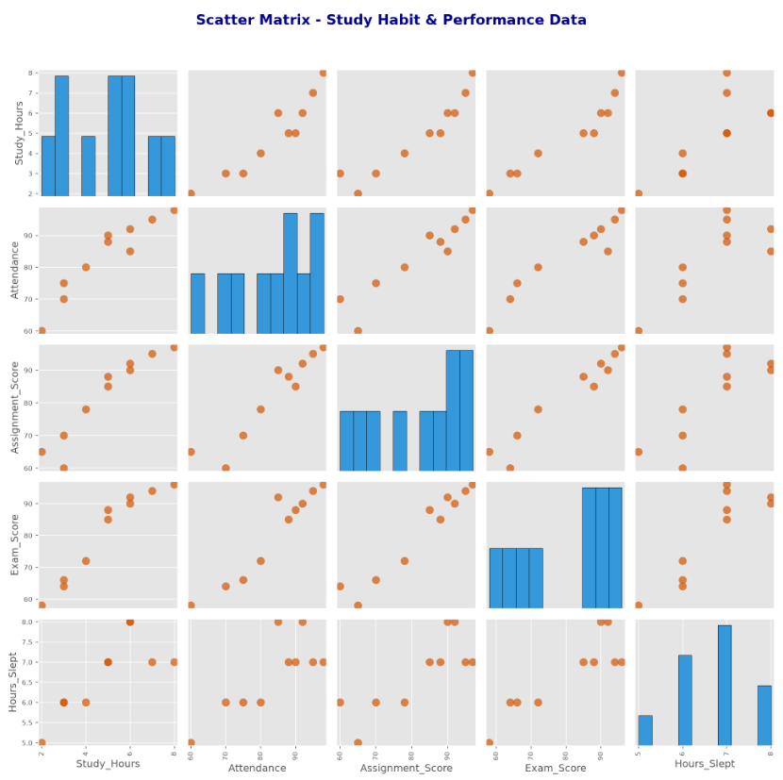

1.12 Advantages
- Provides a complete overview of relationships between all variable pairs in a single figure.
- Saves effort compared to creating separate scatter plots manually.
- Helps in early detection of correlation, trends, and outliers.
- Useful before applying statistical models, since it helps check assumptions such as linearity.
- Easy to interpret visually, even for people without deep statistical background.

1.13 Short Seminar-Ready Summary
A scatter matrix plot is a grid of scatter plots that shows the relationship between every pair of variables in a dataset. The diagonal shows each variable's own distribution, while the off-diagonal cells show pairwise relationships that can be positive, negative, or weak. It is a fast and powerful tool used in exploratory data analysis to understand correlations and detect outliers before deeper analysis or modelling is carried out.

2. Lag Plot Investigation

2.1 Definition of Lag Plot
A lag plot is a special type of scatter plot used for time-series data. Instead of comparing two different variables, it compares a variable's current value with its own past (previous) value. It helps us check whether the values in a time series are related to the values that came before them.

2.2 Meaning of "Lag"
In time-series analysis, "lag" means a delay or a shift by a fixed number of time steps. A lag of 1 (written as lag-1) means comparing each value with the value that occurred immediately before it (one time step earlier). A lag of 2 would compare each value with the value from two time steps earlier, and so on.

2.3 Purpose of Comparing Current Observation with Previous Observation
The purpose of a lag plot is to check whether there is a dependency or pattern between consecutive observations in a time series. This is important because many time-series models (such as forecasting models) assume that past values influence future values. A lag plot gives a simple visual way to test this assumption before building any complex model.

2.4 How a Lag Plot Works
To create a lag plot, we take the time-series data and form pairs of values: each current observation is paired with the observation that occurred one step earlier (for lag-1). These pairs are then plotted as points on a scatter plot, just like a normal scatter plot, but here both axes represent the same variable at different points in time.

2.5 Example: Daily Sales
Consider a shop that records its total sales every day for two weeks. This gives us a simple time series: Day 1 sales, Day 2 sales, Day 3 sales, and so on. To build a lag-1 plot for this data, we pair each day's sales with the previous day's sales, for example (Day 1 sales, Day 2 sales), (Day 2 sales, Day 3 sales), (Day 3 sales, Day 4 sales), and continue this pattern for the rest of the series.

2.6 X-axis and Y-axis Meaning
Axis | Represents
X-axis | The previous observation, y(t − 1) — for example, yesterday's sales
Y-axis | The current observation, y(t) — for example, today's sales

2.7 Sample Code (Python)
The following simple Python code generates a lag-1 plot for a daily sales time series using pandas and matplotlib.
import pandas as pd
import matplotlib.pyplot as plt
from pandas.plotting import lag_plot
# Example daily sales data
sales = [220, 245, 230, 260, 255, 270, 265,
280, 275, 290, 300, 295, 310, 305]
data = pd.Series(sales)
lag_plot(data, lag=1)
plt.title('Lag-1 Plot of Daily Sales')
plt.xlabel('Sales on Day t-1')
plt.ylabel('Sales on Day t')
plt.show()

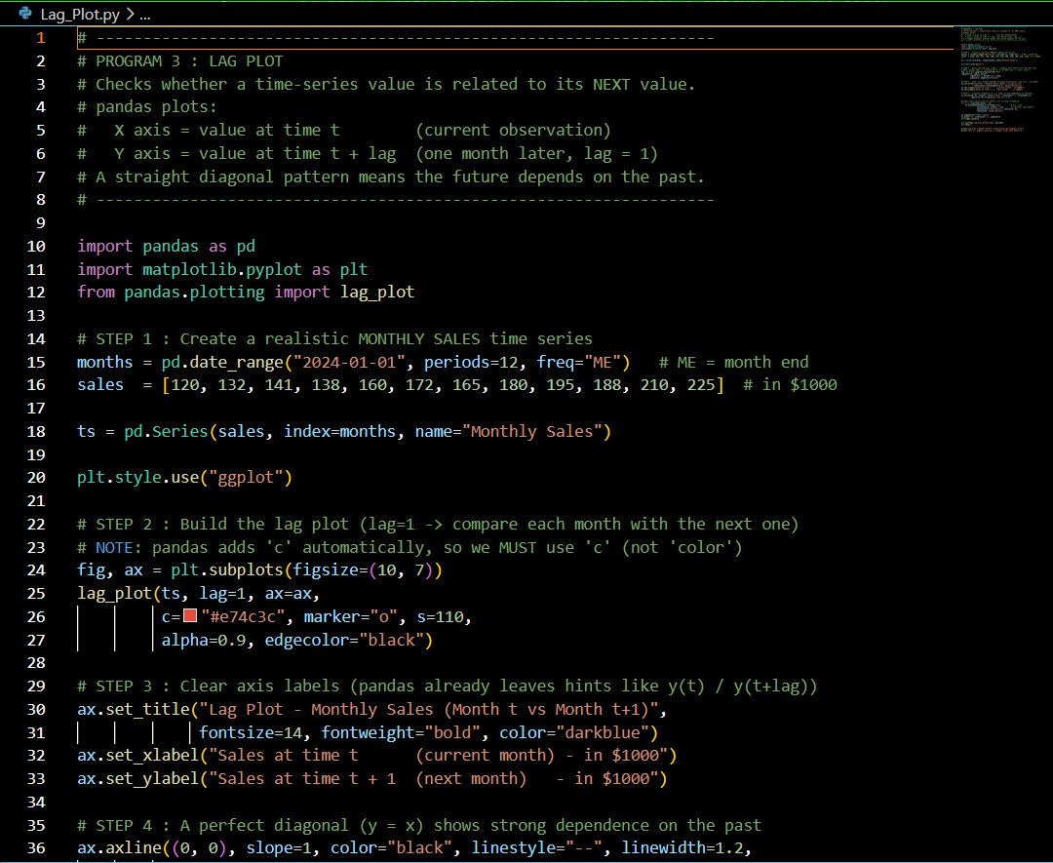

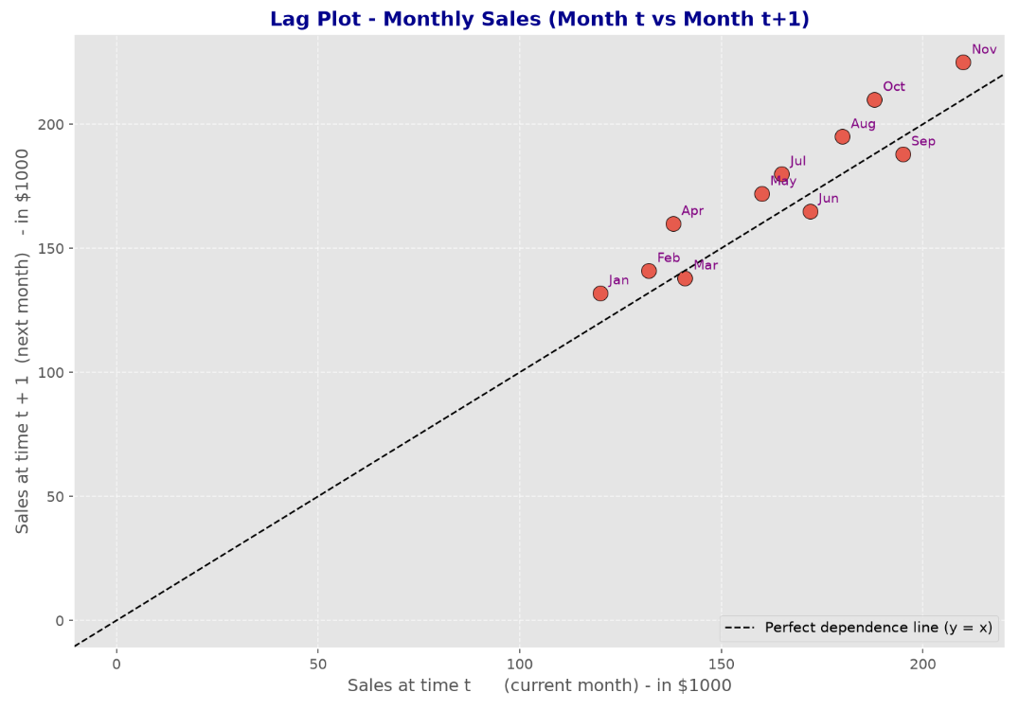

2.8 Examining Whether Current Observations Relate to Previous Ones
Once the lag plot is drawn, we study the arrangement of the points to check for a relationship. If today's sales are consistently close to yesterday's sales, the points will line up in a clear pattern. If today's sales seem unrelated to yesterday's sales, the points will be scattered with no clear shape.

2.9 What a Visible Pattern Means
If the points in the lag plot roughly follow a straight line (especially rising from bottom-left to top-right), it means the data has a strong relationship with its own past values — this is called autocorrelation. This tells us that the time series is predictable to some extent, since knowing today's value gives useful information about tomorrow's value.

2.10 What a Random Scatter Means
If the points are spread out randomly with no visible line or shape, it means there is little or no relationship between consecutive observations. This suggests the data behaves like random noise, and past values do not help in predicting future values — making the series harder to forecast using simple methods.

